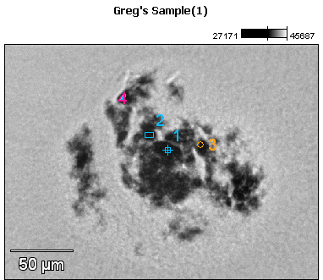

Image Name: Greg's Sample(1)

Image Resolution: 512 by 384

Image Pixel Size: 0.49 µm

Acc. Voltage: 17.0 kV

Magnification: 500

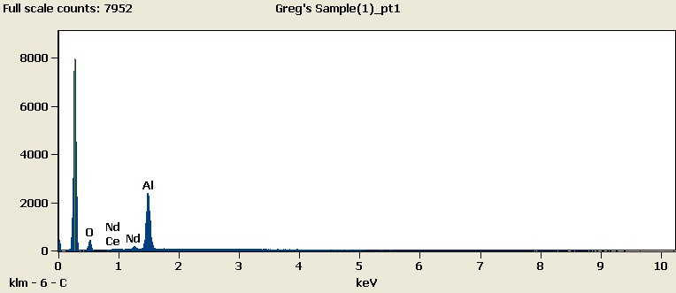

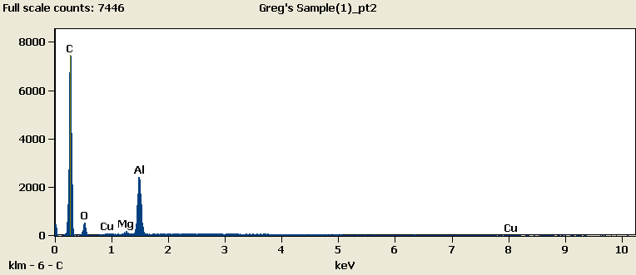

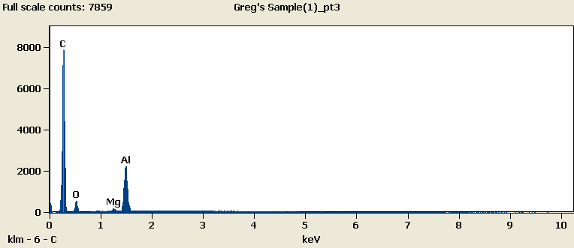

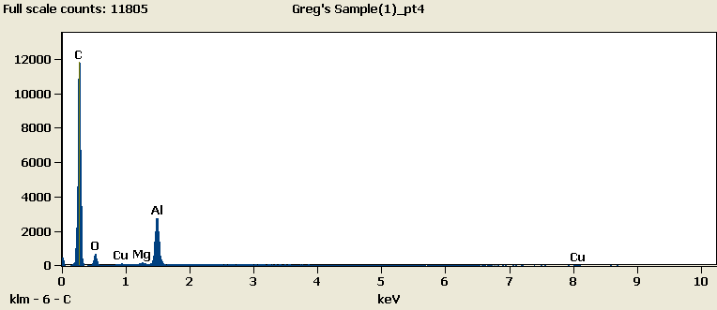

Weight %

|  |  |  |  |  |  |  |  |
| --- | --- | --- | --- | --- | --- | --- | --- |
|  | ***C-K*** | ***O-K*** | ***Mg-K*** | ***Al-K*** | ***Cu-K*** | ***Ce-L*** | ***Nd-L*** |
| ***Greg's Sample(1)_pt1*** |  | 27.83 |  | 72.17 |  | 0.00 | 0.00 |
| ***Greg's Sample(1)_pt2*** | 84.35 | 6.50 | 0.37 | 7.69 | 1.08 |  |  |
| ***Greg's Sample(1)_pt3*** | 85.88 | 6.67 | 0.38 | 7.07 |  |  |  |
| ***Greg's Sample(1)_pt4*** | 87.74 | 5.26 | 0.30 | 6.18 | 0.52 |  |  |

Weight % Error (+/- 1 Sigma)

|  |  |  |  |  |  |  |  |
| --- | --- | --- | --- | --- | --- | --- | --- |
|  | ***C-K*** | ***O-K*** | ***Mg-K*** | ***Al-K*** | ***Cu-K*** | ***Ce-L*** | ***Nd-L*** |
| ***Greg's Sample(1)_pt1*** |  | ±1.60 |  | ±0.76 |  | ±0.00 | ±0.00 |
| ***Greg's Sample(1)_pt2*** | ±0.41 | ±0.35 | ±0.03 | ±0.07 | ±0.18 |  |  |
| ***Greg's Sample(1)_pt3*** | ±0.41 | ±0.36 | ±0.03 | ±0.07 |  |  |  |
| ***Greg's Sample(1)_pt4*** | ±0.34 | ±0.30 | ±0.02 | ±0.05 | ±0.13 |  |  |

# Cations

|  |  |  |  |  |  |  |  |
| --- | --- | --- | --- | --- | --- | --- | --- |
|  | ***C-K*** | ***O-K*** | ***Mg-K*** | ***Al-K*** | ***Cu-K*** | ***Ce-L*** | ***Nd-L*** |
| ***Greg's Sample(1)_pt1*** |  | 0.00 |  | 0.00 |  | 0.00 | 0.00 |
| ***Greg's Sample(1)_pt2*** | 0.00 | 0.00 | 0.00 | 0.00 | 0.00 |  |  |
| ***Greg's Sample(1)_pt3*** | 0.00 | 0.00 | 0.00 | 0.00 |  |  |  |
| ***Greg's Sample(1)_pt4*** | 0.00 | 0.00 | 0.00 | 0.00 | 0.00 |  |  |